Sample Lesson Plans

for DollarBay

Developed by CS345 Spring 2004

Team Members:

Chauncey Klein Robert Maeyaert
Daniel O'Donnell Jared Rupprecht
Ryan Sandness Brandon Seifert
Instructors Guide

Weekly Progress Reports
If you plan on playing the DollarBay simulation for more than a few days, the Weekly Progress Report can be a tool to have the students analytically think about how their store is doing, and track their progress as the simulation continues.

Creation of Account
Do this exercise first
All players of DollarBay will need their own login. We recommend using FirstNameLastname or FLastName naming convention. So your users will be JohnDoe or JDoe respectively. If you like, you can have your student write down their username and password so they can remember it if you plan on playing over a longer time period. We recommend that students keep their passwords the same as their name to avoid confusion as well as being easier to access by the instructor if needed.

Staff Intro
Do this exercise second
The purpose of this exercise is to have the student hire an employee to run the store. You cannot sell any product unless you have an employee in your store. The amount you pay for your employee determines the quality and services your employee provides. For example, higher paid employees will attempt to stop returns or theft from your store.
Encourage students to interact with all the characters and other students in DollarBay.

Introduction to Inventory
Do this exercise third
The purpose of this exercise is to purchase some inventory so that the stores can start operating. The shoppers in DollarBay have set lists of things they are looking to purchase. To maximize the students’ stores making sales, they should have several products in a product line. For example, they should focus on being a hardware store, not a Wal-Mart strategy of selling some of everything. Customers know what type of products you sell, not what items you sell. Therefore, a student is more likely to make a sale if they have beds, dressers, and night stands.
In addition, the teacher should try to encourage students to have different types of stores. This will make sure that the market is not flooded with Pet stores.

Running the Stores
The first three exercises should be done in the same sitting if possible. Gameplay cant run on its own until you have an employee and some product to sell. Each student will now have to run the business. Students should do market research to see what kinds of products are selling in their city as well as who lives there. Each student should pick at least one form of advertising, that best fits their store and city, to attract customers. Students will also have to watch the prices of their competitors in order to keep customers.

Navigation Key
This exercise is designed to let the students navigate the DollarBay map.
X represents warehouses.
Blue star represents the student’s store.
The green dollar sign represents the bank.
The yellow star represents the Hall of Fame.

Scavenger Hunt
This exercise is intended as an exercise to let the students get familiar with the different stores in DollarBay, as well as see the variety of products offered for sale by the catalogs.

Scavenger Hunt Key

- The American Flag is a seasonal item that may be found at The Discount Warehouse. There are a limited number in stock so you may not be able to get one. The price of the Flag is $40 each or $35 for 10 or more. Seasonal items tend to be in demand during a certain season.
- The High Quality Lamp can be found in two places. First it can be found at The Living Room Warehouse for the price of $40 each or $30 for 5 or more. It can also be found in the Discount Catalog for $80 each or $60 for 5 or more. The catalog is much more expensive as well as charging for shipping and handling.
- The Professional Chainsaw is a tool can be found in The Tool Shed. The price is $275 each or $250 for 5 or more.
- Exotic Monkeys as Pets is a book that can be found at Wild Things Animal Wholesale, one of three pet stores in Dollar Bay. The price is $15 each or $12 for 5 or more.
- Happy Halite is one of the minerals that can be purchased in the game and it can be found at Rock Heads, at the price of $80 each or $65 for 5 or more.
- The Single Disk DVD Player is an item that cannot be found in stores and can only be purchased from the Electronic Direct catalog. The price of the player is $65 each or $50 for 5 or more. This will also have a charge for shipping since it is purchased through the catalog.
- Waveless is a high quality waterbed that can be found at Furniture-Mart Wholesale. The price of the bed is $600 each or $525 for 5 or more.

Banks
Not a critical exercise, but one that can help students realize that borrowing money comes at a cost, and that it isn’t a fix all solution.

Demographics
This can be a difficult topic to discuss, so make sure this lesson is age appropriate. Students can make sales without doing any market research, but they can do much more business if they can market to the right crowd.

Account Setup

Name:___________________________
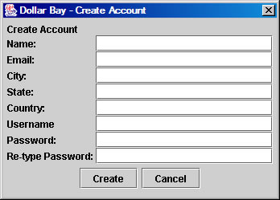

The first thing you must do is create a new account. You must choose a login name and password.
Each time you return, you will put in your unique login name and password.

Username:__________________

Password:___________________

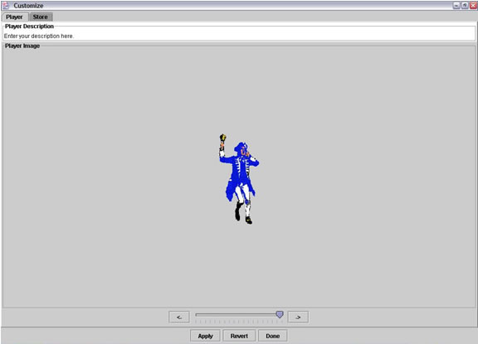

The first time you play you must choose your player. Scroll through the options, using the slider at the bottom of the screen. Choose one then click apply and then done.

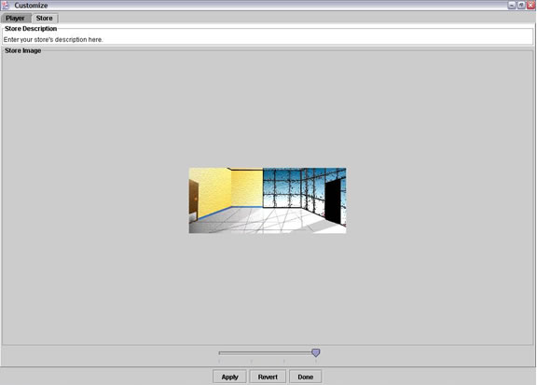

Next choose a store. Do so the same way you chose a person. Move the slider left or right until you find a suitable choice. Select Apply when finished.

You have now finished your initial setup of your store at DollarBay. See Lesson Plan 2 for more information….
Staffing
Name:__________________________
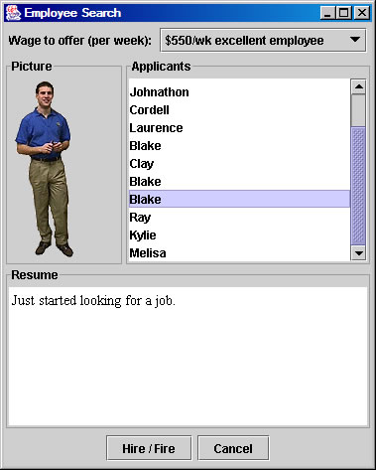

On the main DollarBay menu, click on the “Hiring” button.

You should begin business by hiring an employee. You have a few different options regarding the price of an employee. You can hire an employee who has no experience for $200 per week. You can hire someone who has some experience for $350 per week, or hire someone with more experience for $450 or $550 per week.
Once you find an adequate employee, click the Hire/Fire button to hire your employee.

1.) Enter the name of your hired Employee:

2.) How much are you paying your employee a week?

Once you have an employee, try clicking on him/her. Your employee can talk with you and provide you with reports about your store. Try asking him/her some questions.

3.) List a question that you think might be important, as a store manager.

You can interact with any other character in DollarBay. You can also type into the text box in the main menu to enter custom welcome messages to customers or enter into conversations with other DollarBay participants.
Inventory
Name:______________________________

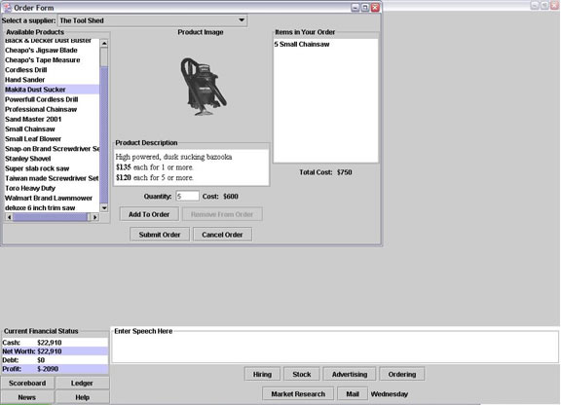

Now that you have a store and an employee, we need something to sell. Click on “Ordering” on the main menu to bring up a list of items available through the catalog. Choose what type of store you would like to be. Examples are Hardware Store, Furniture Store, Pet Store, etc…

Take a look at all the different products there are available for purchase. There is a pull down menu at the top that will allow you to select one of many different catalogs. Notice that there is a purchase price and MSRP. The purchase price is what you will pay for the item now, and the MSRP is what the recommended selling price is. HINT: The larger the difference between purchase price and MSRP means a higher profit for you. Try to spend $5000 or less to acquire at least 15 items of inventory between 2 or more different products.
When you find an item that you want to purchase, select it and type in the quantity you would like to order. Verify you can afford the purchase, and select “add to order” to select multiple products, or “submit order” to finish purchase.

- What type of store are you?

2.) Which supplier did you order from?

- What are the items you purchased to sell?

4.) How much profit are you making on each item?

Navigation
Name: ________________________________

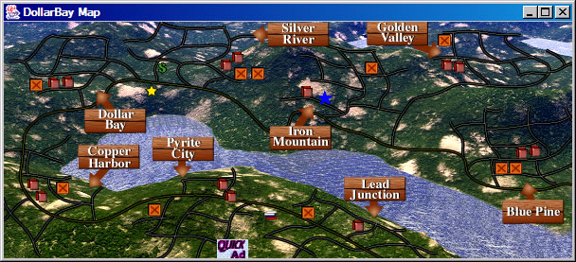

- What do the brown X marked icons represent?

- What does the blue star represent?

- What town are you located in or around?

- What does the green Dollar symbol represent?

- What does the yellow star represent?

Demographics
Name:_____________________________

Demographics are defined as a subset of people that are being specifically targeted. The town you live in has a certain population, so you need to make sure to sell products that your customers are going to want to buy. Advertising is how to let your demographic group that you exist. People can’t shop at our store if they do not know it exists right? For example, if you are aiming at professionals you would want to advertise in the business section of the newspaper. The size of your advertisement also makes a difference the effectiveness of your campaign. Cost varies with each ad; therefore, it is important not to spend too much advertising on the wrong crowd.
This brings up the importance of market research covered in the next section. Answer the following questions using the lists below.

To find out who lives in your area and what to sell (more importantly) market research is essential. There are many different reports available to you through the market research function. The ones we are going to focus on are the area market and customer preference.

To begin, click the “Market Research” button, then the “Market Target” button.

1.) Find out what your geographical target market is.

2.) Find out what your target market wants.

3.) What type of advertising should be used?

4.) If your top customer is CYM2HCNH? How should you advertise? Include Costs.

5.) If your second customer is CYAWARM? How should your advertise? Include Costs.

Shopper Types – Reference Sheet

CYM2HCNH: (Y)oung,Upscale (M),(H)omeowners, (C)ouples,(N)o Kids,(H)ighly Educated
C_HPSH2W: (H)igh Income,(P)rofessionals,Large Older Homes (S),(H)omeowners, (W)ell Educated
CML2RPF1: (M)iddle-Age,(L)ow Income(R)enters,Female Headed House (P),(F)ewer Kids
CYBC_R3: (Y)oung,(B)elow Average Income,(C)ollege,(R)enters
C_HWNHC2: (H)igh Income, (W)hite Collar,(N)ew Homes,(H)omeowners,New Families (C)
C_W_PH_F1: (W)ealthy,Prestige Older Homes (P),(H)omeowners,(F)ew Kids
C_HWCM3: (H)igh Income,(W)hite Collar,High Value Apartments and Condos (C),(M)ixed
C_HPHRS_H: (H)igh Income,(P)rofessionals,(H)igh Rent Apartments,(R)enters,(S)ingle, (H)ighly Educated
CEMRTM_F1: (E)lderly,(M)iddle-income,(R)etirees,Apartments and (T)own Homes,(M)ixed, (F)ew Kids
CEMLAR3: (E)lderly,(M)iddle-income,Professional & White Collar Retirees (L),(A)partment Dwellers,(R)enters
C_A_RHFK1: (A)verage Income, Low Value Homes (R),(H)omeowner,Younger (F)amilies,(K)ids
CMA_AR_F1: (M)iddle-Age,(A)verage Income,(A)partment Dwellers,(R)enters,(F)ewer Kids
CYAWARM2: (Y)oung,(A)verage Income,(W)hile Collar,(A)partment Dwellers,(R)enters,Very (M)obile Singles
CMB_OM_F1: (M)iddle-Age,(B)elow Average Income,(O)lder Home,(M)ixed,(F)ew Kids
CMA_VH3: (M)iddle-Age,(A)verage Income, Low (V)alue Older Homes,(H)omeowner
CYB_LRM2: (Y)oung,(B)elow Average Income,(L)ow Rent Apartments,(R)enters, Very (M)obile
CYA_HRM2: (Y)oung,(A)verage Income,(H)igh Rent Apartments,(R)enters,(M)obile
CYL2RM_A: (Y)oung,(L)ow Income,(R)enters,Very (M)obile Singles,(A)verage Education
CML_LR_F1: (M)iddle-Age,(L)ow Income,(L)ow Rent Apartments,(R)enters,(F)ew Kids
CYBB_MFM1: (Y)oung,(B)elow Average Income,(B)lue Collar Laborers,(M)ixed,Large (F)amilies, (M)any Kids

Banks

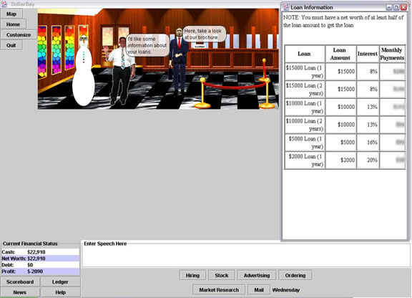
Name:_______________________

Click on the “Map” button in the upper left hand corner. Find the green dollar sign ($) icon. You are now at the bank. Click on the banker to talk to him. Ask him for information on loans. Then ask for more information and all of the questions within that dialog.

1.) If you have a net worth of $6,168.32 will you be able to take out a loan for $15,000?

2.) How about a loan for $2,000?

3.) What would your monthly payments be on a two year $10,000 loan?

4.) What would your interest rate be on a one year $2,000 loan?

Advertising

Name:____________________

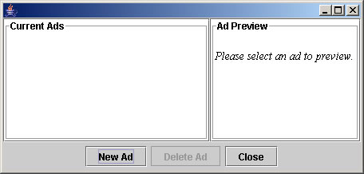
Click on the “Advertising” button at the bottom of the screen. A menu will popup where you can view your current ads, or create new ads. You will want to select the “New Ad” button. You are now in the advertising forum. From here you can choose either the radio or the newspaper for your advertising and how much you want to advertise. Click on a few different options to answer the following question.

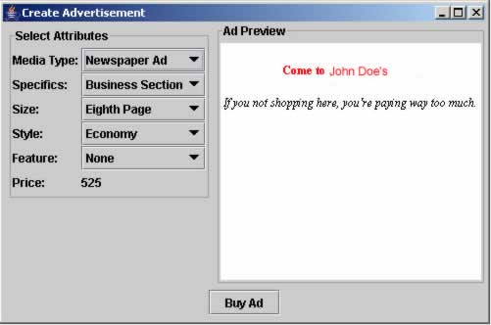

1.) If you want to advertise on the radio for 30 min/day how much will it cost?

2.) How about in the newspaper for a half page ad? Make sure to list what options you used for your ad.

3.) List the type of store you plan to open and what type of advertising you will use.

4.) What advertising would you use to attract people in a lower income community to your electronics store?
Weekly Progress Report
Name:

Date:

1. What sales did you make the past week?

2. What sales did you lose?

3. What is your net worth, amount of cash and total debt? How much of an increase/decrease is it from the week before?

4. What kind of advertising are you using? Do you think that it is working?

5. What changes do you feel need to be made to make your store more profitable?

Discussion Questions

- What are some of the factors that make a good place to shop?
- What are some of the reasons that motivate you to make the purchase?
- What types of products or purchases would you buy on the spot and which ones would make you shop around?
- What factors would cause you to take out a loan or borrow money?
- Is borrowing money always a bad thing?
- What are some of the ways people can go about selling products without starting a business?
- How has the Internet influenced your shopping habits?
- What are some of the factors that cause a business to fail?
- How do sales people influence your buying habits?
- When working at a business, how important is it to set goals?
- What are some of the methods you would use when determining a selling price?
- What would you do if you did not have or were out of stock of the product that people were trying to buy?
  - Would you recommend a substitute?
  - Would you recommend the place that had what they were looking for?
- What is better, selling many of a few products or selling a few of many products?
  - What are the advantages and disadvantages of both?
- How would you go about figuring out who is your target market?
- Do you need to select a target market when opening a business?
- How important is marketing for a business?
- How do you determine how much to spend on marketing?
- How do you select which medium to use to market your products? (i.e. tv, radio, magazines, Internet)
- How do you know when it is time to close the doors if you were a business owner?
- How do you decide how much to pay your employees?
- How is selling to teenagers different than selling to retired seniors?
- What are the advantages and disadvantages of owning your own business versus working for a business owner?
- What are some methods you would use to finance a business venture?
Demographics Questions

Dollar Bay
Demographics Section

Activity #1:
- Have students individually or in groups make a list of some of the important things to consider when they are making an important purchase.
- Pick random students to read some of the items on their list and discuss.
- Discuss how some of the things that they feel are important when making a purchase is different from other age groups.

Activity #2
- Have students enter Dollar Bay.
- Instruct each student to look up 5 different demographic groups in the game and write them down.
- Have each student write down information on what they think are the unique buying habits of each group.
- Then have them compare and contrast the differences amongst all of the groups.

Discussion Questions
The following are class discussion questions on demographics. Use these questions to encourage thinking about the subject matter before, during, and after game play.

- What are demographics?
- How has the Internet changed the way people shop?
  - For teenagers?
  - For Young adults?
  - For Parents?
  - For Grandparents?
- How is selling to teenagers different than selling to retired seniors?
- If you were a car salesperson, how would your selling techniques be different for each age group?
- What are the advantages and disadvantages of selling the product in the same manner to every customer that comes through the door?

Scenarios

The following are probable real life scenarios involving demographics. Use these to encourage real life role playing.
- You are about to open your own business selling bikes and biking gear. You have been a long time biking enthusiast and member of several local biking clubs. Using your own background, how would you go about figuring out which group is best to market your products towards?
- Demographic trends show that in the next five years there will be a very large group of people retiring from their jobs. As someone who wants to become an entrepreneur and capitalize on this market with a product or service, how would you decide where to begin your business venture?

